*Video 1, here raw image is converted to string*

1. we are using **pdf2image** and **poppler**(it is installed in my system) to convert the pdf file into text file
2. pages = convert_from_path(r'docs\prescription\pre_1.pdf', poppler_path=r'C:\poppler-23.08.0\Library\bin')……(1)first argument is the address of pdf to be converted.(2)poppler path tells us actually where the dependencies are located.
3. pages[0].show()----this shows the converted image file
4. pages—it is an array of PIL (or Pillow is a library for image processing) images
5. pytesseract—it has a function called image_to_string(function used as pytesseract.image_to_string(pages)) that converts the text in the image to string. You can also specify the language of the document. It uses google’s tesseract ocr engine to convert image to string

*video 2 , here image will be processed using open cv and then converted to string*

1. 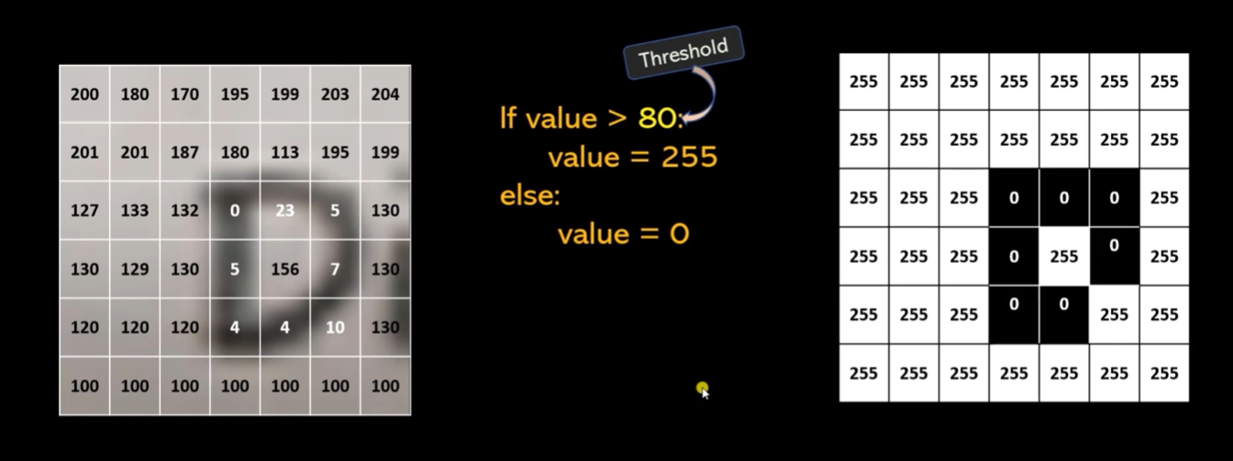

We first convert the image into a binary image using some threshold value. This is ***simple thresholding.***

1. But if image be of this type then simple thresholding would cause a problem.

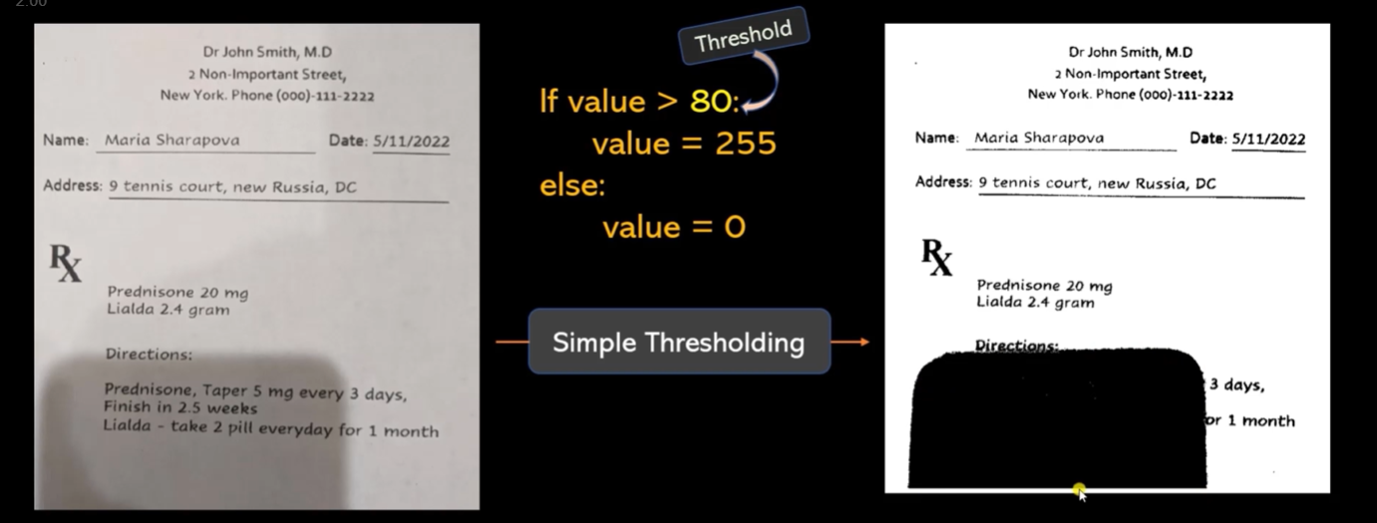

1. We use ***adaptive thresholding*** to avoid this problem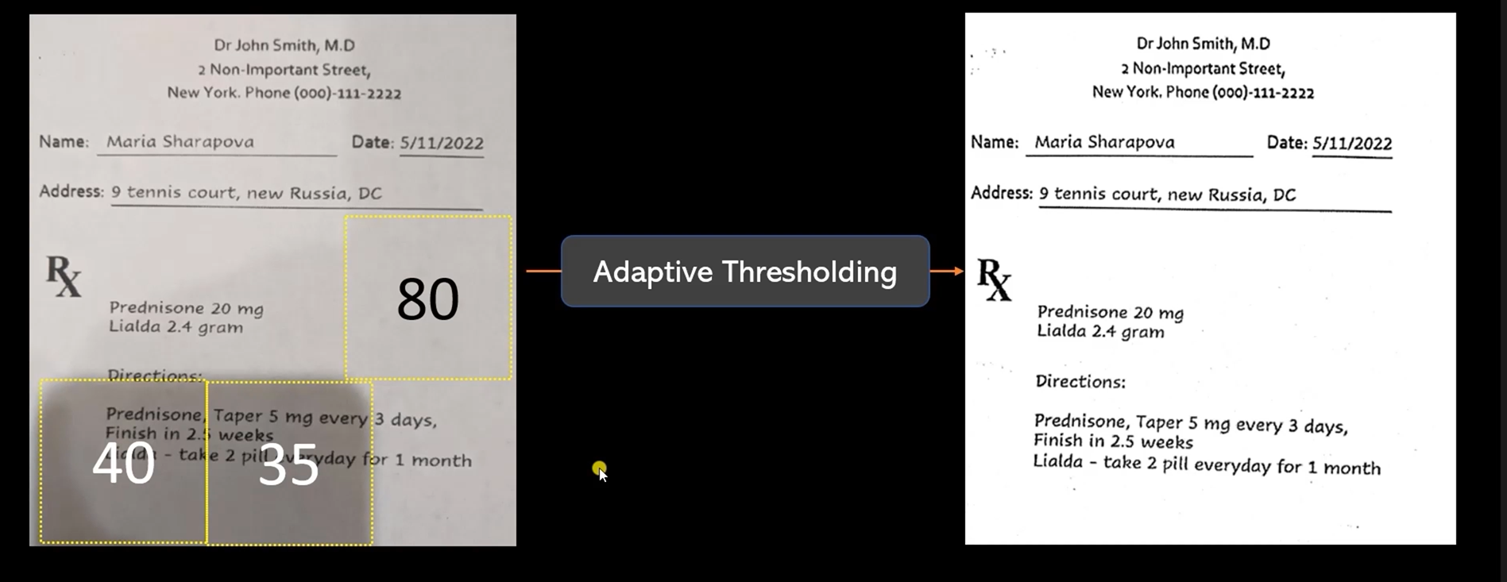

[OpenCV: Image Thresholding](https://docs.opencv.org/4.x/d7/d4d/tutorial_py_thresholding.html)

1. In adaptive thresholding the threshold value is calculated by- (a) The threshold value is the mean of the neighbourhood area minus the constant C(ADAPTIVE_THRESH_MEAN_C) (b) The threshold value is a gaussian-weighted sum of the neighbourhood values minus the constant C. (ADAPTIVE_THRESH_GAUSSIAN_C)

Video3, Here comes the use of regular expressions to find information from the string

1. The module to use regex expressions in python is re.
2. pract

Fastapi server Notes

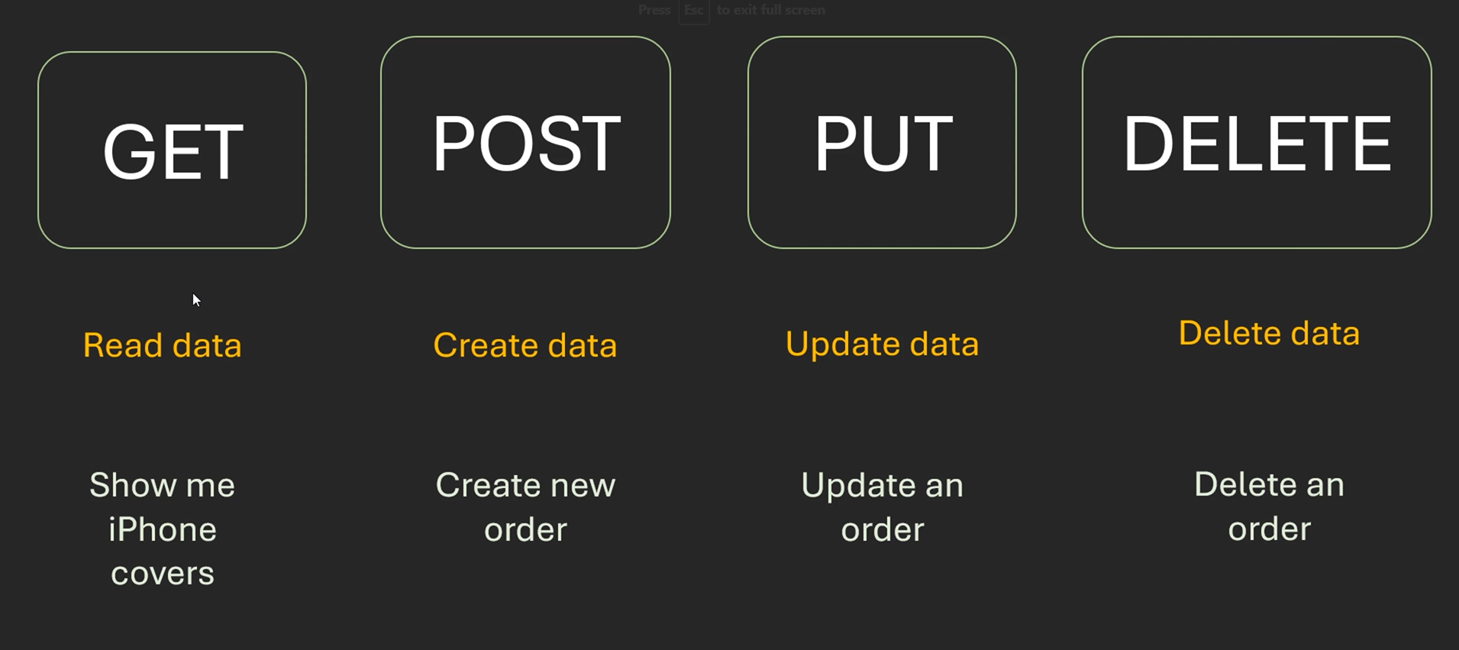

2 fastapi provides inbuilt data validation